Join us for an
Ohio Wins Gathering!
_______________ ______________

with Former Ohio Governor
RICHARD CELESTE
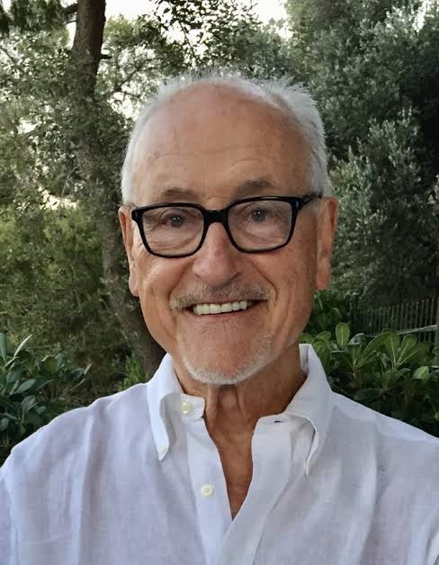
Thursday, September 10, 2026
 2:00pm – 4:00pm
The Weber House | 414 Wayne Street
Sandusky 44870
MEET. CONNECT. DISCUSS STATE AND LOCAL ELECTIONS.
This will be a relaxed, informal, casual opportunity to ask questions, share ideas, and connect with like-minded neighbors and friends. Light snacks & beverages.

Let’s build a stronger Ohio – together!

Erie County Democratic Party | Printed In-House | www.eriecountydems.org
Not endorsed by any local, state, or federal candidate or candidate’s campaign.

