Due to inclement weather including
minus degree temperature/windchill,
this event has been postponed!
Please stay tuned as we reschedule for a later date!

Ohio Democratic Party Chairwoman

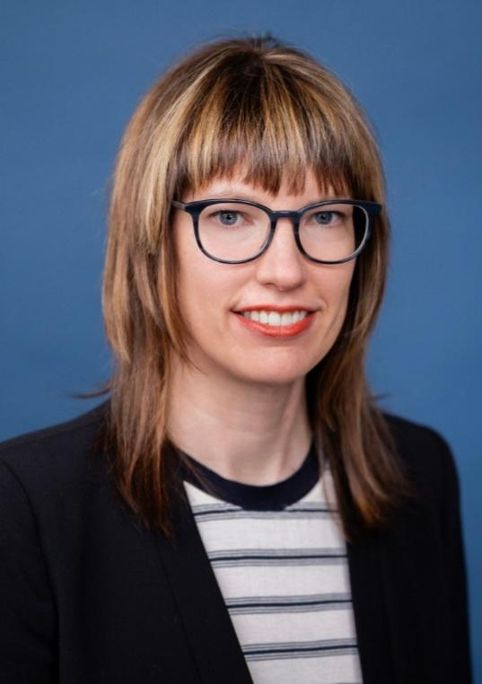

Kathleen Clyde
For a conversation to hear directly from
the leader of Ohio Democrats
about the challenges, opportunities and the road
we face ahead together in 2026 and beyond.

**POSTPONED**
TUESDAY, JANUARY 27, 2026
5:30pm – 7:00pm

The Weber House | 414 Wayne Street | Sandusky 44870
One of the oldest and beautiful homes in Sandusky

Please RSVP no later than Friday, January 23, 2026, please contact:
MaryAnn Groot | Treasurer/ECDP | 419.202.5031 (cell/text)
Erie County Democratic Party | www.eriecountydems.org | Printed In-House | Labor Donated
Not authorized by any local, state, federal candidate or candidate’s committee.

